**Name:- Samreen Shaikh Roll no:- 64**

**Subject:- Big Data Analytics Date:- 28/01/2025**

**PRACTICAL - 13**

**HADOOP INSTALLATION AND SETUP**

**INSTALLATION:**

**STEP I: *Install Hadoop 3.3.1 from the official website of Apache and extract in the C drive folder.***

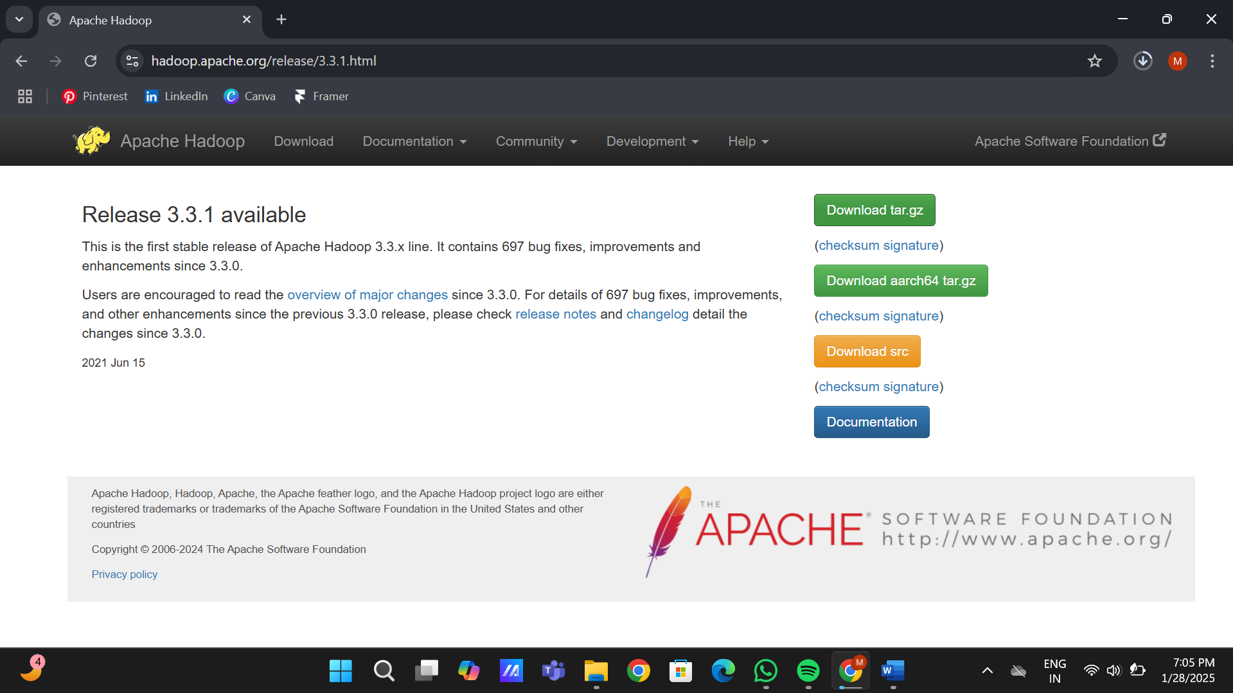

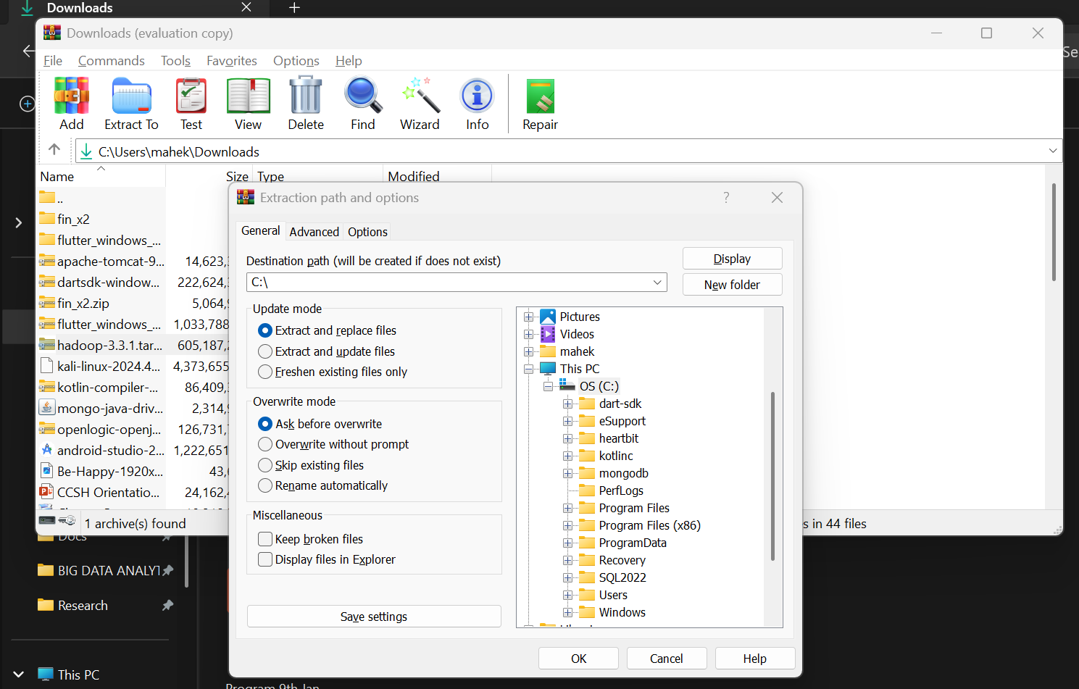

**STEP II: *Set path of HADOOP_HOME as given below***

**System Variable : *C:\hadoop-3.3.1***

**Path (Set 2 path for bin and sbin) :**

***C:\hadoop-3.3.1\bin***

***C:\hadoop-3.3.1\sbin***

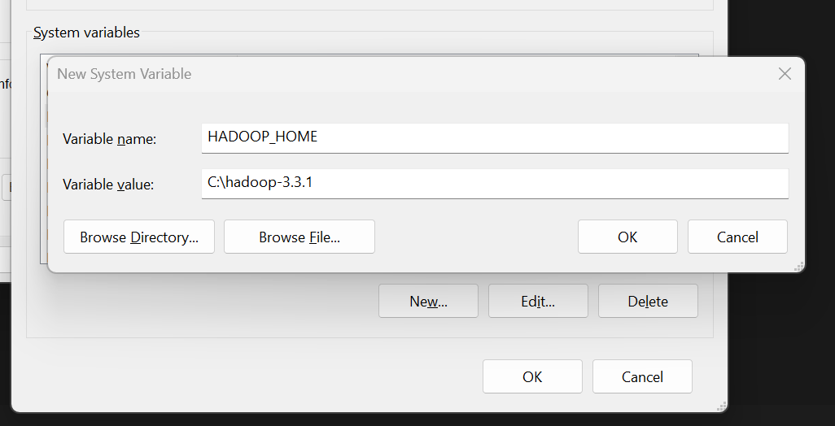

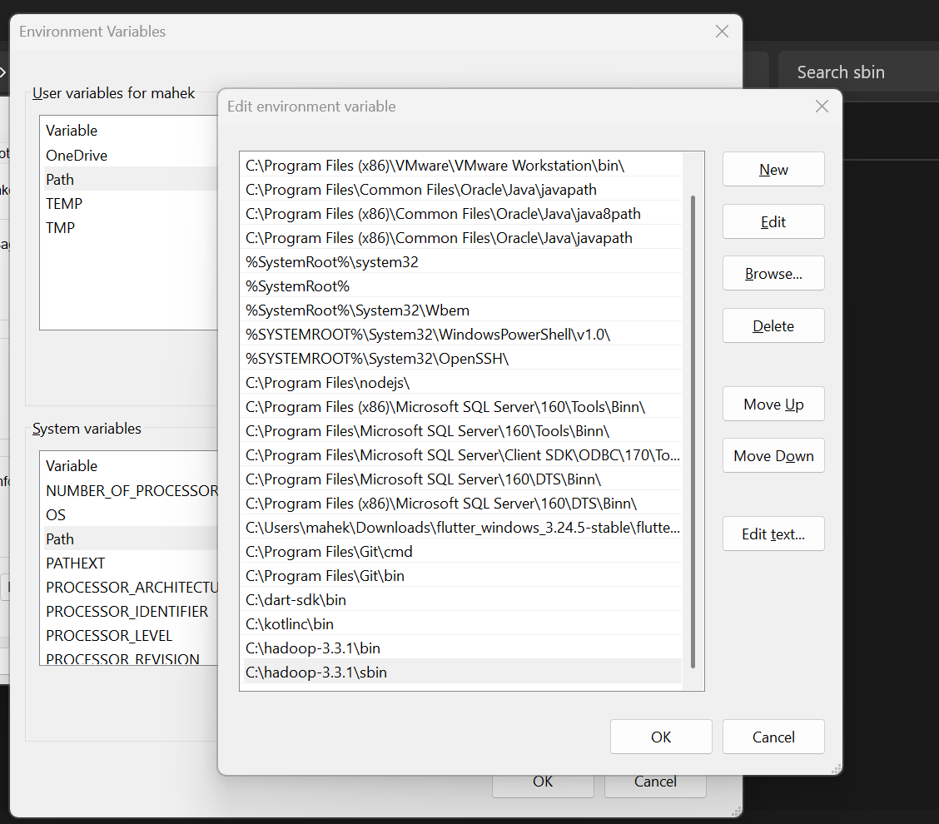

**STEP III: *Setup JAVA_HOME path in the system environment variable. Make sure jdk is in the C drive exactly where the Hadoop 3.3.1 folder is extracted.***

**JAVA_HOME: *C:\jdk-1.8\***

**Path : *C:\jdk-1.8\bin***

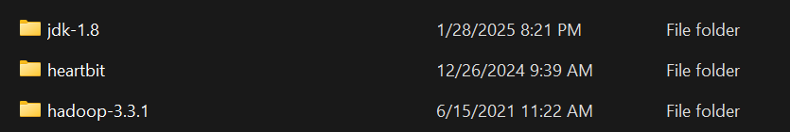

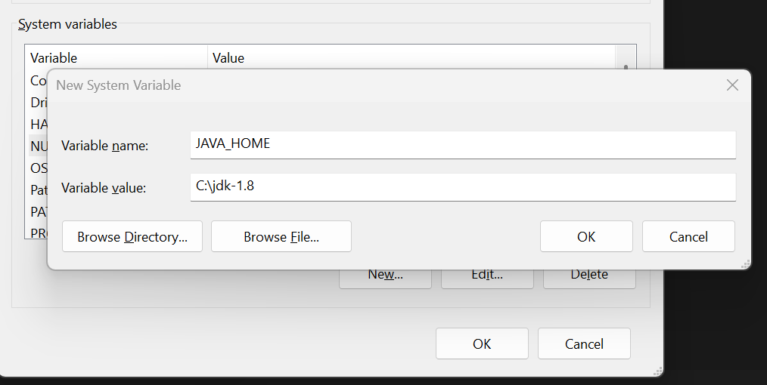

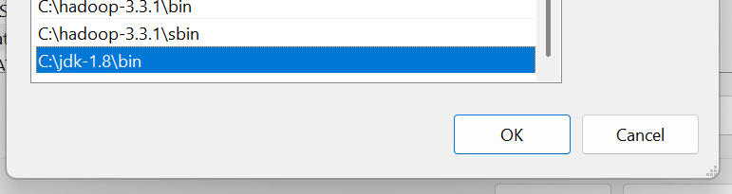

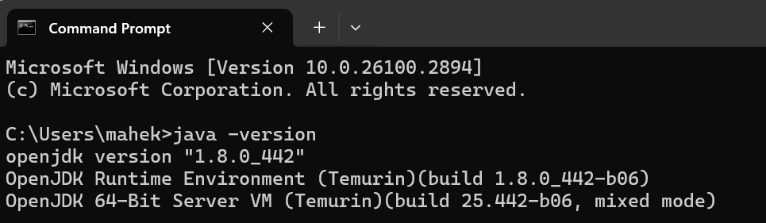

**STEP V: Make folder data in Hadoop 3.3.1 folder and make namenode and datanode folders in the newly created data folder.**



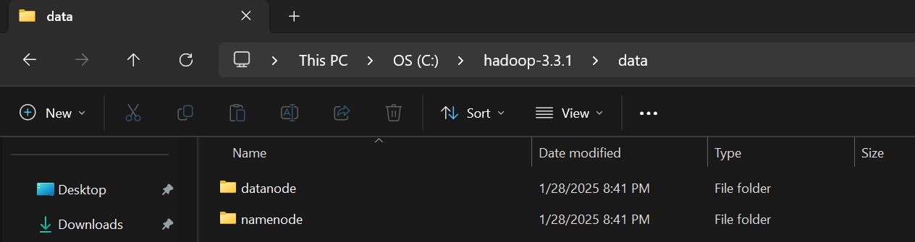

**STEP V: Now make the changes in the code in the files of location C:\hadoop-3.3.1\etc\hadoop as follows**

**core-site.xml**

<property>

<name>fs.defaultFS</name>

<value>hdfs://localhost:9000</value>

</property>

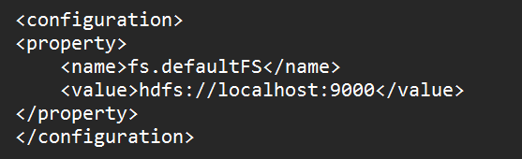

**hdfs-site.xml**:

<property>

<name>dfs.replication</name>

<value>1</value>

</property>

<property>

<name>dfs.namenode.name.dir</name>

<value>file:///C:/hadoop/tmp/dfs/name</value>

</property>

<property>

<name>dfs.datanode.data.dir</name>

<value>file:///C:/hadoop/tmp/dfs/data</value>

</property>

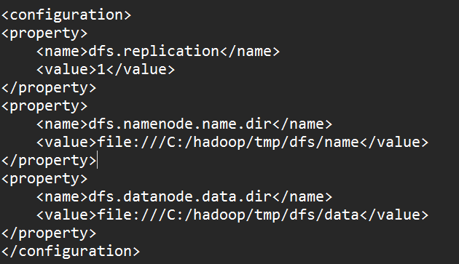

**mapred-site.xml**:

<property>

<name>mapreduce.framework.name</name>

<value>yarn</value>

</property>

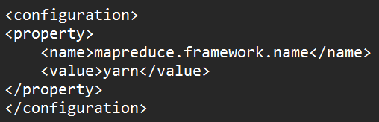

**yarn-site.xml**:

<property>

<name>yarn.resourcemanager.address</name>

<value>localhost:8032</value>

</property>

<property>

<name>yarn.nodemanager.aux-services</name>

<value>mapreduce_shuffle</value>

</property>

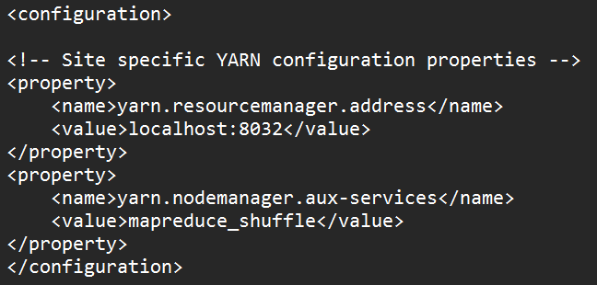

**hadoop-env.cmd : *Uncomment and add the JAVA_HOME Path* in this file.**

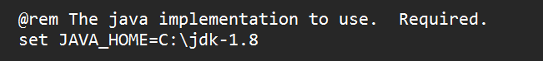

**STEP VI: *Download Hadoop utils for Hadoop 3.3.1 and replace the original bin with the new bin folder.***



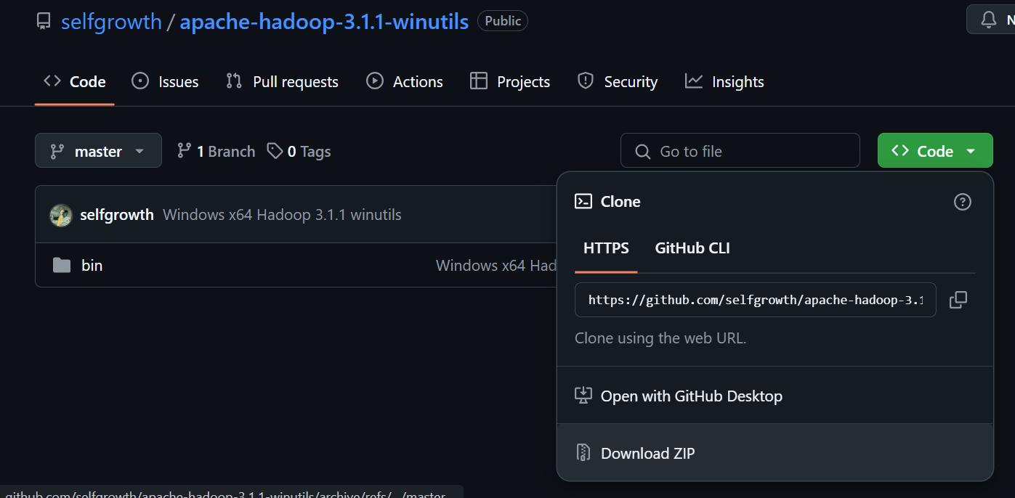

***Copy this bin and replace with original bin in Hadoop.3.3.1 folder.***

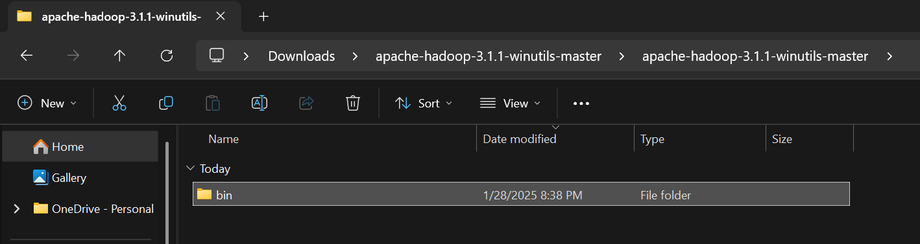

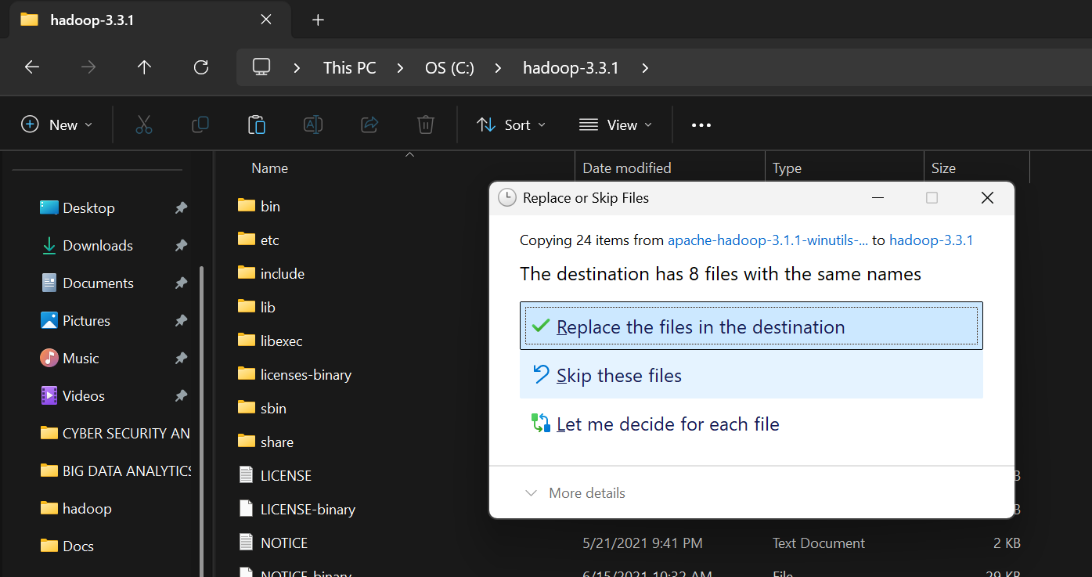

**STEP VII: *Open Command prompt as administrator and cd to the the bin path in Hadoop and type this command to format the name node.***

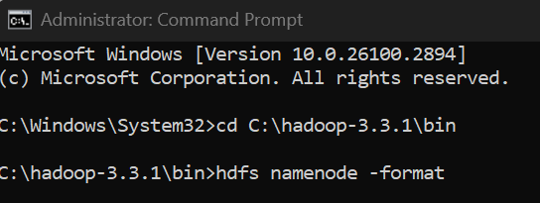

**STEP VIII: *Change directory to sbin and Start the dfs and yarn cmd.***

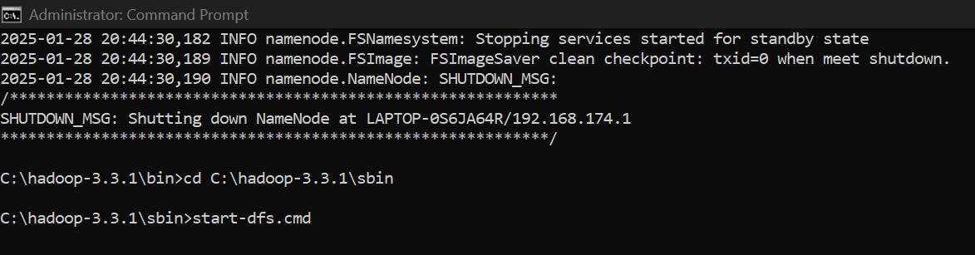

**These 2 windows will open**

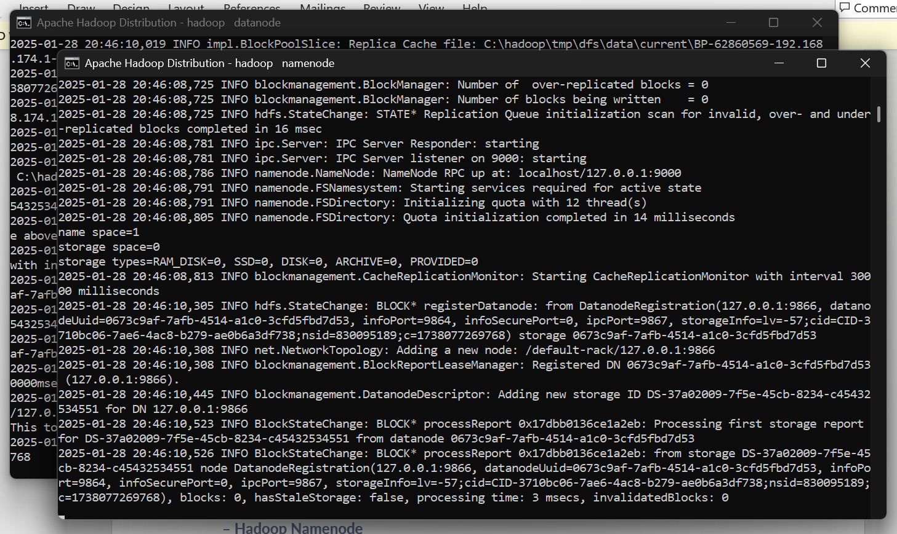

**STEP IX: *Start the yarn cmd* .**

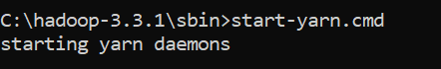

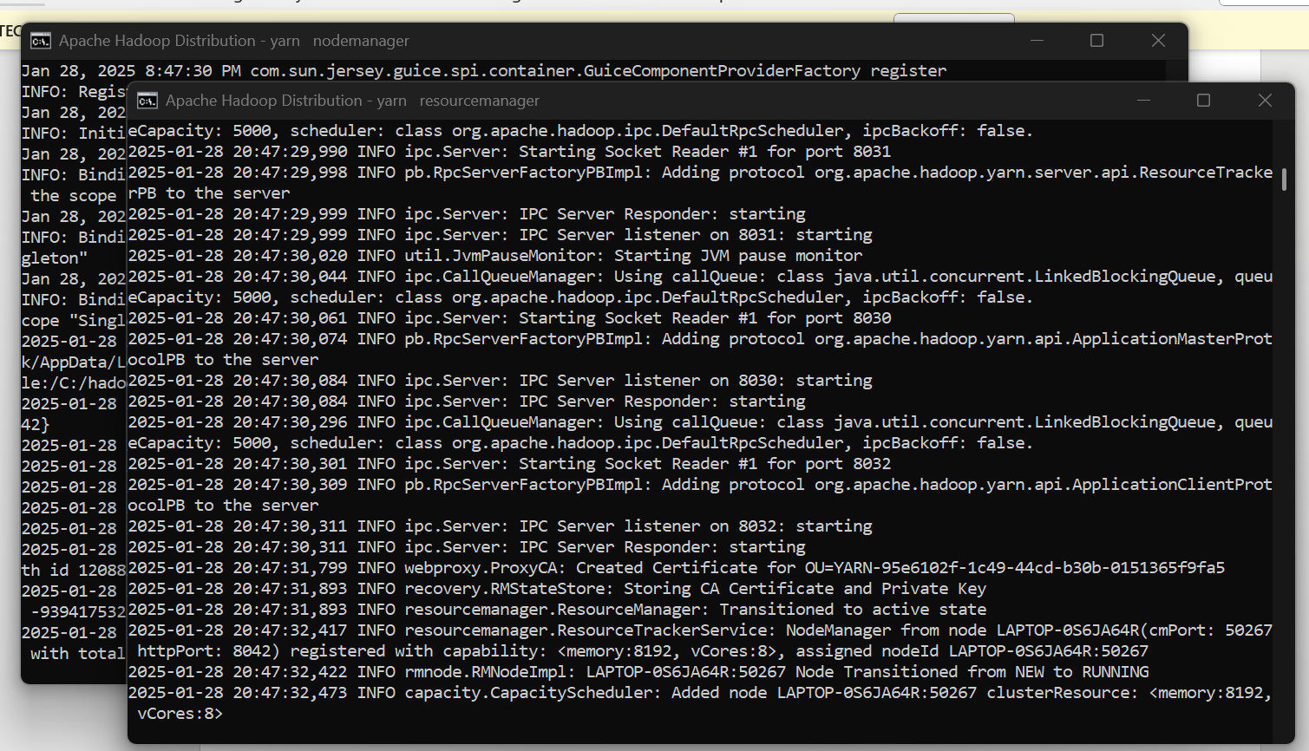

**STEP X: *Type localhost:8088 on web browser.***

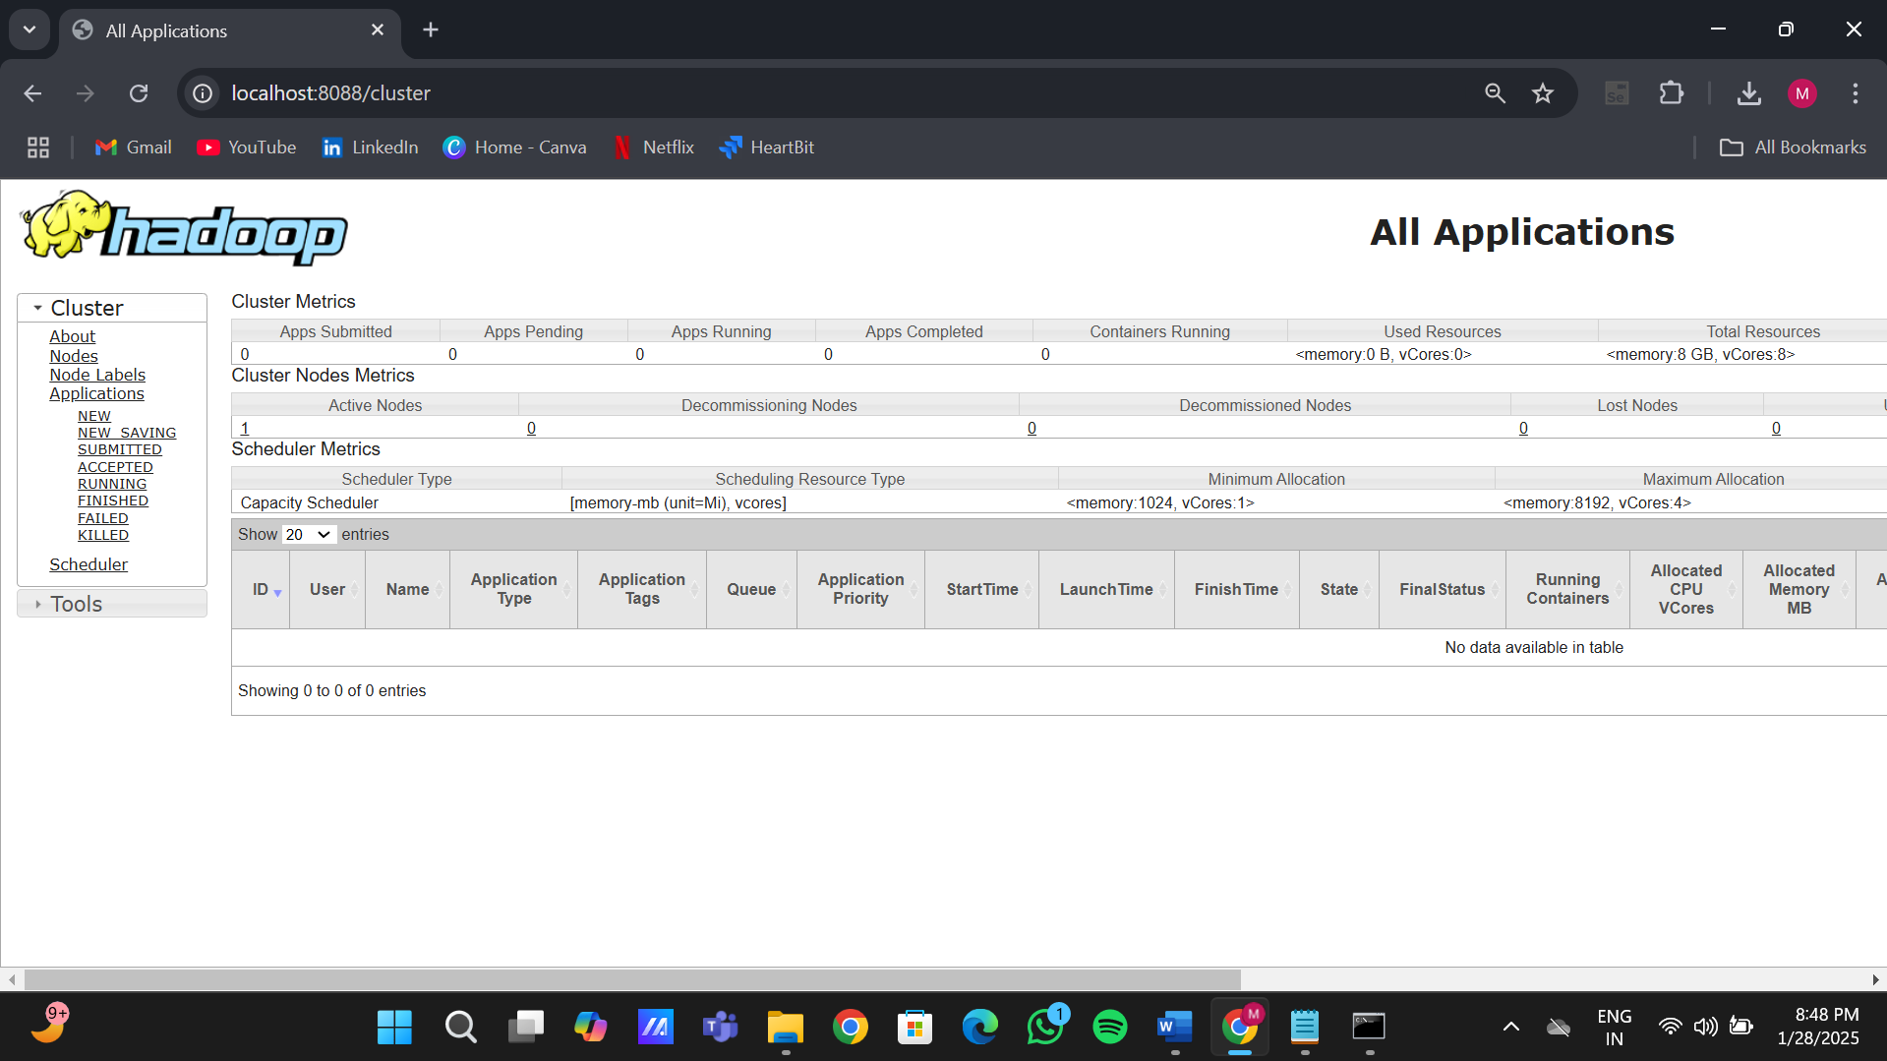

**STEP XI: *Type localhost:9870 on web browser.***

